CSC 352 / 452: Database Programming
REVIEW OF BASIC ORACLE SQL FEATURES

1. Review of Basic Oracle SQL Features

This course will help you to understand the basics of programming in PL/SQL with appropriate examples. It shows how PL/SQL meets the challenges of database programming, and how you can reuse techniques that you know from other programming languages.

Even though the programming concepts discussed in this class is specific to Oracle PL/SQL, the concepts like cursors, procedures and functions can be used in other database systems like Microsoft SQL Server, Sybase etc., with some changes in syntax.

Previous experience in at least one high-level programming language is expected; this is not an introductory programming course. In particular, you should already have written programs using branching (e.g., “IF-ELSE”), looping (e.g., “WHILE”), functions (or procedures), and arrays.

Please note that you must understand basic SQL factures before we actually start getting into PL/SQL concepts.

This course has many examples. You will need to run them and play with them. There is probably no more effective way to learn programming than to fiddle with examples.

In today’s lecture, we will review some basic SQL statements.

1.1 Oracle SQL Developer

Oracle SQL Developer is a free graphical tool designed to improve your productivity and simplify the development of everyday database tasks. It simplifies the following tasks:

- Browsing and managing database objects
- Executing SQL statements and scripts
- Editing and debugging PL/SQL statements
- ……

You can connect to any target Oracle database schema by using standard Oracle database authentication. When connected, you can perform operations on objects in the database.

You may download Oracle SQL Developer (free) software from Oracle via the link:

http://www.oracle.com/technology/products/database/sql_developer/index.html

(https://ipdapp.cdm.depaul.edu/sqldeveloper/)

1.1.1 Installing Oracle SQL Developer

Oracle SQL Developer does not require an installer. To install Oracle SQL Developer, you will need an unzip tool.

1) To install and start Oracle SQL Developer, follow these steps:

Unzip sqldeveloper.zip into a directory (folder) of your choice (for example: c:\)

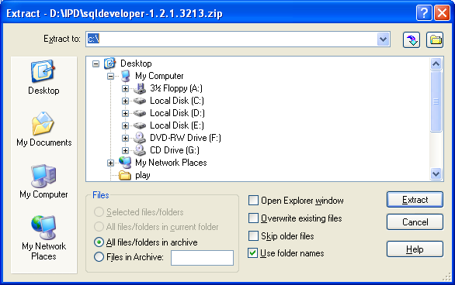

Unzipping sqldeveloper.zip causes a directory named sqldeveloper to be created under the C directory. It also causes many files and folders to be placed in and under that directory.

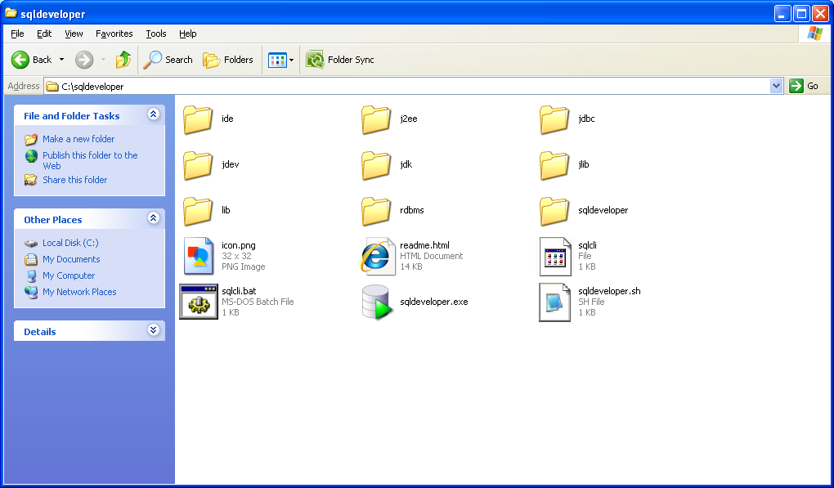

2) To start Oracle SQL Developer, go to the c:\sqldeveloper directory, and then double-click sqldeveloper.exe.

1.1.2 Database Connections

A connection is an Oracle SQL Developer object that specifies the necessary information for connecting to a specific database as a specific user of that database. You must have at least one database connection to use Oracle SQL Developer.

To create a connection from your Oracle SQL Developer to our database server, follow these steps:

- Right-click the Connections node in Oracle SQL Developer’s Connections Navigator, and click New Database Connection to open the New/Select Database Connection dialog box.

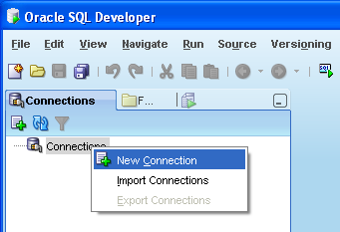

- Use the dialog box to specify information about the connection.

Connection Name | An alias for a connection to the database using the information that you enter (e.g., csc452).
Username | It should be same as your CSTCIS account login name.  (Do not put “CSTCIS” as prefix of your user name)
Password | The password for your Oracle account.  (The default is “cdm” plus last 7 digits of your DePaul student ID, e.g., cdm0123456.)
Save Password | Do NOT check it if that is a public or shared computer.  You may check it if that is a private computer.
Oracle | Access | | Oracle
Role | This is the set of privileges to be associated with the connection. Accept default for this connection.
Connection Type | Select Basic from the Connection type list.
OS Authentication | Leave this unchecked for this connection.
Proxy Connection | Leave this unchecked for this connection.
Host Name | This is the host system for the Oracle Database instance. Enter 140.192.30.211 for this connection.
Port | This is the listener port for the database. The default port for Oracle Database is 1521.
SID | This is the system identifier. Enter def for this connection.
Service Name | This is the network service name of the database. Leave this unchecked for this connection.

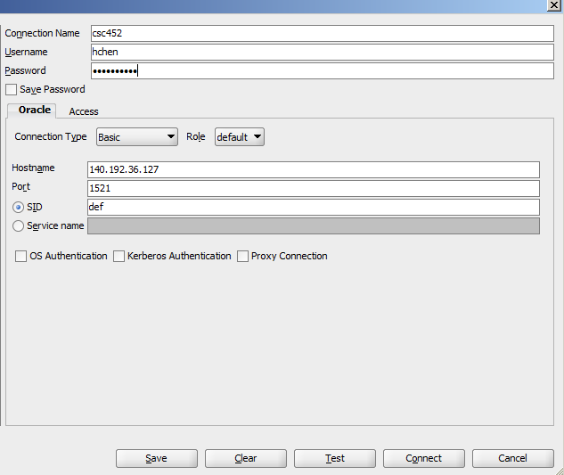

- Click Test to validate the new connection.

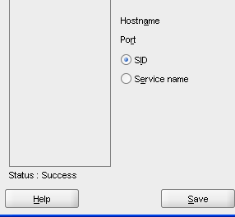

- If your test reports “Status: Success”, click Connect. The Oracle SQL Developer will save the new connection, close the dialog box, and connect to the database. (If you click Save instead of Connect, you will be able to create more new connections in the dialog box before connecting.)

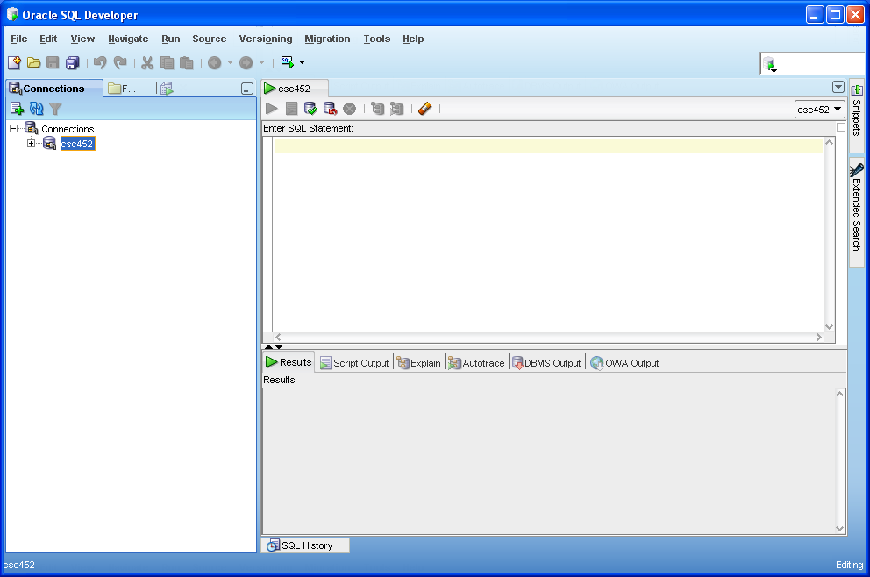

1.1.3 Oracle SQL Developer User Interface

1) Once you have a database connection, you are ready to browse the schema, query and modify data.
The Oracle SQL Developer window generally uses the left side for navigation to find and select objects, and the right side to display information about selected objects.

You can use the SQL Worksheet to enter and execute SQL, PL/SQL, and SQL*Plus statements. You can specify any actions that can be processed by the database connection associated with the worksheet, such as creating a table, inserting data, creating and editing a trigger, selecting data from a table, and saving that data to a file.

You can display a SQL Worksheet by right-clicking a connection in the Connections navigator and selecting Open SQL Worksheet, by selecting Tools and then SQL Worksheet, or by clicking the Use SQL Worksheet icon under the menu bar.

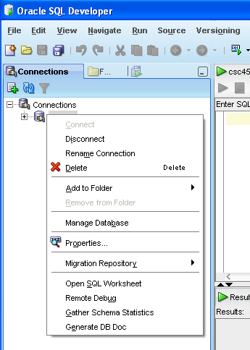

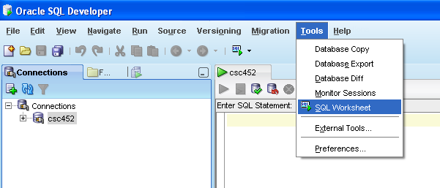

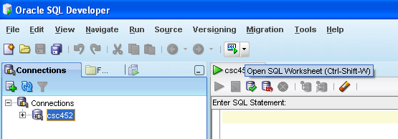

2) Now, you should see the Enter SQL Statement window.

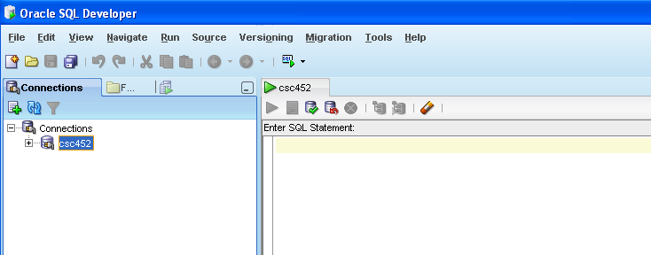

SQL Worksheet toolbar (under the SQL Worksheet tab): Contains icons for the following operations:

Execute Statement (F9) executes the statement at the mouse pointer in the Enter SQL Statement box.

Run Script (F5) executes all statements in the Enter SQL Statement box using the Script Runner.

Commit (F11) writes any changes to the database, and ends the transaction; also clears any output in the Results and Script Output panes.

Rollback (F12) discards any changes without writing them to the database, and ends the transaction; also clears any output in the Results and Script Output panes.

Cancel (Ctrl-Q) stops the execution of any statements currently being executed.

Clear (Ctrl-D) erases the statement or statements in the Enter SQL Statement box.

Enter SQL Statement: The statement or statements that you intend to execute. For multiple statements, each non-PL/SQL statement must be terminated with either a semicolon or (on a new line) a slash (/). SQL keywords are automatically highlighted.

Results: It displays the results of the most recent Execute Statement (F9) operation.

Script Output: It displays the output if you clicked the Run Script (F5).

Example

1) Creating the DEPARTMENT table

You need to erase the statements in the Enter SQL Statement box before enter your statements.

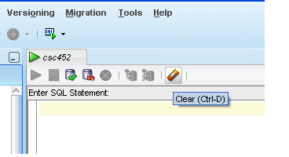

Enter

CREATE TABLE department
( DEPARTMENT_ID NUMBER(4) PRIMARY KEY,
DEPARTMENT_NAME VARCHAR2(20),
ADDRESS VARCHAR2(20));

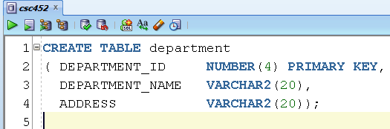

Click Run Scripts (F5), and then click Script Output.

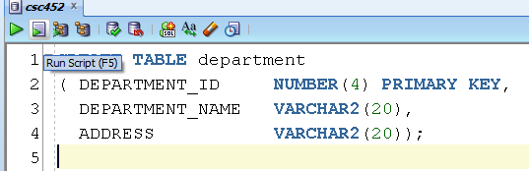



Right-click Tables, select Refresh, and expand the Tables node. Now you have seen the columns that define the table.
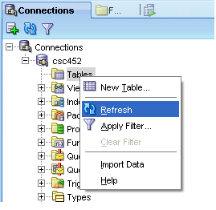

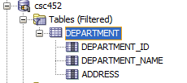

2) Populating the DEPARTMENT table

You need to erase the statements in the Enter SQL Statement box before enter your statements.
Enter

INSERT INTO department VALUES(10, 'ACCOUNTING', 'NEW YORK');
INSERT INTO department VALUES(20, 'RESEARCH', 'DALLAS');
INSERT INTO department VALUES(30, 'SALES', 'CHICAGO');
INSERT INTO department VALUES(40, 'IT', 'DALLAS');
INSERT INTO department VALUES(50, 'EXECUTIVE', 'NEW YORK');
INSERT INTO department VALUES(60, 'MARKETING', 'CHICAGO');
COMMIT;

Click Run Scripts (F5).

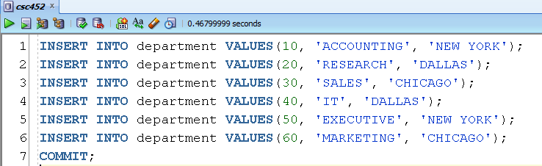

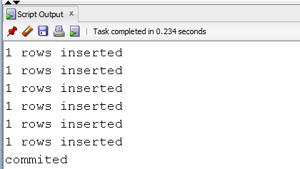

3) Displaying all the data in the DEPARTMENT table.

Enter

SELECT * FROM department;

Click Run Scripts (F5).

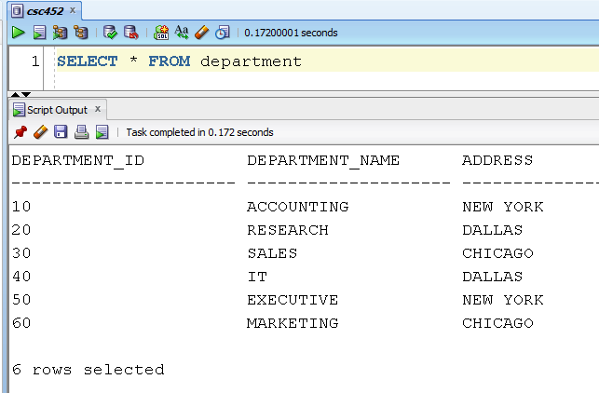

4) Creating the EMPLOYEE table

Enter

CREATE TABLE employee
( EMPLOYEE_ID NUMBER(4) PRIMARY KEY,
EMPLOYEE_NAME VARCHAR2(20),
JOB VARCHAR2(50),
MANAGER_ID NUMBER(4),
HIRE_DATE DATE,
SALARY NUMBER(9, 2),
COMMISSION NUMBER(9, 2),
DEPARTMENT_ID NUMBER(4) REFERENCES department(DEPARTMENT_ID));

Click Run Scripts (F5).

5) Populating the EMPLOYEE table

Erase the statement in the Enter SQL Statement box, and then enter

INSERT INTO employee
VALUES(7839, 'KING', 'PRESIDENT', NULL, '17-NOV-81', 5000, NULL, 50);
INSERT INTO employee
VALUES(7698, 'JOST', 'VICE PRESIDENT', 7839, '01-MAY-81', 4500, NULL, 50);
INSERT INTO employee
VALUES(7782, 'CLARK', 'VICE PRESIDENT', 7839, '09-JUN-81', 4000, NULL, 50);
INSERT INTO employee
VALUES(7566, 'JONES', 'PUBLIC ACCOUNTANT', 7698, '02-APR-81', 3000, NULL, 10);
INSERT INTO employee
VALUES(7568, 'STEEL', 'PUBLIC ACCOUNTANT', 7566, '02-MAR-83', 2500, NULL, 10);
INSERT INTO employee
VALUES(7654, 'WILSON', 'ANALYST', 7698, '28-SEP-81', 3000, NULL, 20);
INSERT INTO employee
VALUES(7499, 'WOLFE', 'ANALYST', 7654, '12-FEB-82', 2500, NULL, 20);
INSERT INTO employee
VALUES(7844, 'LEE', 'ANALYST', 7654, '01-SEP-86', 2400, NULL, 20);
INSERT INTO employee
VALUES(7900, 'FISHER', 'SALESMAN', 7782, '03-DEC-81', 3000, 500, 30);
INSERT INTO employee
VALUES(7521, 'JACKSON', 'SALESMAN', 7900, '22-FEB-85', 2500, 400, 30);
INSERT INTO employee
VALUES(7902, 'LANCASTER', 'SALESMAN', 7900, '03-DEC-86', 2000, 150, 30);
INSERT INTO employee
VALUES(7910, 'SMITH', 'DATABASE ADMINISTRATOR', 7698, '17-DEC-81', 2900, NULL, 40);
INSERT INTO employee
VALUES(7788, 'SCOTT', 'PROGRAMMER', 7910, '09-DEC-82', 2500, NULL, 40);
INSERT INTO employee
VALUES(7876, 'ADAMS', 'PROGRAMMER', 7910, '12-JAN-83', 2000, NULL, 40);
INSERT INTO employee
VALUES(7934, 'MILLER','PROGRAMMER', 7876, '22-JAN-82', 1000, NULL, 40);
COMMIT;

Click Run Scripts (F5).

6) Displaying all the data in the EMPLOYEE table.

Enter

SELECT * FROM employee;

Click Run Scripts (F5).
1.2 Basic Oracle SQL Features

This course is designed for students who have basic experience with SQL. Before learning Oracle PL/SQL, you should understand the following SQL features.

1.2.1 SQL Statements

SQL Statements
CREATE, ALTER, DROP, TRUNCATE, … | Data definition language (DDL)
SELECT | Data retrieval
INSERT, UPDATE, DELETE, … | Data manipulation language (DML)
COMMIT, ROLLBACK, … | Transaction control
GRANT, REVOKE, … | Data control language (DCL)

1.2.2 Creating Tables

The CREATE TABLE Statement

Example

CREATE TABLE department_employee
( DEPARTMENT_ID NUMBER(4),
EMPLOYEE_ID NUMBER(4),
INSERT_TIME DATE);

You can display the structure of a table using the DESCRIBE command. The result of the command is to see the column names, data types, and whether a column must contain data.

Example

DESC department_employee

1.2.3 Manipulating Data

1) The INSERT Statement

You can add new tuples to a table by using the INSERT statement.

Example

INSERT INTO department VALUES (70, 'SHIPPING', NULL);
COMMIT;
Example

INSERT INTO
department_employee (department_id, employee_id, insert_time)
SELECT department_id, employee_id, sysdate
FROM employee;
COMMIT;

2) The UPDATE Statement

You can modify existing tuples by using the UPDATE statement.

Example

UPDATE department
SET address = 'NEW YORK'
WHERE department_id = 70;

3) The DELETE Statement

You can remove existing tuples from a table by using the DELETE command.

Example

DELETE FROM department WHERE department_id = 70;

If the WHERE clause is omitted, all tuples in the table will be deleted.

Example

DELETE FROM employee;
ROLLBACK;

1.2.4 Writing Basic SELECT Statements

A SELETE statement retrieves information from the database.

1) Selecting ALL Columns

Example

SELECT * FROM employee;

2) Selecting Specific Columns

Example

SELECT employee_name, department_id FROM employee;

3) Using Arithmetic Operator

Example

SELECT employee_name, salary, 1.1 * salary FROM employee;

4) Using Column Aliases

Example

SELECT employee_name, salary, 1.1 * salary AS New_Salary FROM employee;

5) Concatenation Operator

Example

SELECT employee_name, '$' || 1.1 * salary AS "NEW SALARY" FROM employee;

6) Using the DISTINCT Clause

The default display of queries is all tuples, including duplicate tuples. You can use the DINTINCT keyword in the SELECT clause to eliminate duplicate tuples.

The DISTINCT keyword is intended to include only unique rows in the result set. When SQL encounters a Null value, this field is considered empty with no data. Empty fields are considered equal for the purposes of the DISTINCT keyword; only one NULL is selected no matter how many empty fields are encountered.

Example

SELECT DISTINCT job FROM employee;

7) Limiting the Tuples Selected

You can restrict the tuples returned from the query by using the WHERE clause. A WHERE clause contains a condition that must be met, and it directly follows the FROM clause.

a) Comparison Conditions

=, >, >=, <, <=, <>, !=,
BETWEEN...AND..., IN (set), LIKE, NOT LIKE, IS NULL, IS NOT NULL

Example

SELECT employee_name, salary
FROM employee
WHERE salary < 2500;

Example

SELECT employee_name, salary
FROM employee
WHERE salary BETWEEN 2500 AND 3000;

The IS NULL operator tests for values that are null. You cannot test with “=” because a null value cannot be equal or unequal to any value.

Example

SELECT employee_name
FROM employee
WHERE commission IS NULL;

To check if a value is not null, you must use the "IS NOT NULL" syntax.

Example

SELECT employee_name,
salary,
commission,
ROUND(commission / (salary + commission) * 100, 2) || '%' PCT
FROM employee
WHERE commission IS NOT NULL;

b) Logical Conditions

AND, OR, NOT

You may need to specify complex criteria by combining several search conditions. The AND and OR operators may be used to make compound logical expressions.

Example

SELECT employee_name, salary
FROM employee
WHERE department_id = 30 AND salary < 2500;
Example

SELECT employee_name, salary
FROM employee
WHERE department_id = 30 OR salary < 2500;

8) Sorting the Tuples Selected

While retrieving data from the database, you may need to specify the order in which the tuples are displayed. The order of tuples returned in a query result is undefined. The ORDER BY clause may be used to sort the tuples. If used, you must place the ORDER BY clause last. You can specify an expression or use position to sort.

[ORDER BY {column_name, expr, alias} [ASC | DESC]];
ASC - orders the tuples in ascending order. (This is the default order.)
DESC - orders the tuples in descending order.

Null values are displayed last for ascending sequences and first for descending sequences.

Example

SELECT employee_name, salary
FROM employee
ORDER BY salary, employee_name;

Example

SELECT employee_name, salary
FROM employee
ORDER BY salary, employee_name desc;

Example

SELECT employee_name, salary
FROM employee
ORDER BY salary desc, employee_name desc;

Example

SELECT employee_name, salary
FROM employee
ORDER BY salary desc, employee_name;

You can order by columns that are not in the SELECT list.

Example

SELECT employee_name, job
FROM employee
ORDER BY department_id;

9) SQL Functions

a) UPPER (string)/ LOWER (string)

The UPPER function converts all letters in the specified string to uppercase.
The LOWER function converts all letters in the specified string to lowercase.

Example

SELECT department_id
FROM employee
WHERE UPPER(employee_name) = UPPER('Smith');

The LOWET function converts all letters in the specified string to lowercase.

Example

SELECT department_id
FROM employee
WHERE LOWER(employee_name) = 'smith';

b) LPAD (string, length [, pad-string])
RPAD (string, length [, pad-string])

The LPAD function returns an expression, left-padded to a specified length with the specified characters; or, when the expression to be padded is longer than the length specified after padding, only that portion of the expression that fits into the specified length.

To right-pad a text expression, use RPAD.

Example

SELECT employee_name, LPAD(salary, 5, ' ') AS SALARY
FROM employee
WHERE employee_id > 7839

Example

SELECT LPAD(employee_name, 20, ' ') AS EMPLOYEE_NAME,
LPAD(salary, 5, ' ') AS SALARY
FROM employee
WHERE employee_id > 7839

c) TO_CHAR(number | date, ['fmt'])
It converts a number or date value to a VARCHAR2 character string with format model fmt.

Example

SELECT TO_CHAR(salary, '$99,990.00') SALARY
FROM employee
WHERE UPPER(employee_name) = 'SMITH';

The TO_CHAR function allows you to convert a date from the default format to one specified by you.

Example

SELECT TO_CHAR(hire_date, 'MM/DD/YYYY') HIRE_DATE
FROM employee
WHERE UPPER(employee_name) = 'SMITH';
Example

SELECT TO_CHAR(hire_date, 'DAY') || ', '
|| TO_CHAR(hire_date, 'DD-MON-YYYY') HIRE_DATE
FROM employee
WHERE UPPER(employee_name) = 'SMITH';

Example

SELECT TO_CHAR(sysdate, 'DD-MON-YYYY HH:MM:SS') FROM dual;

(DUAL is a table which is created by oracle along with the data dictionary. It consists of exactly one column whose name is dummy and one record. The value of that record is X. The owner of dual is SYS but dual can be accessed by every user.)

d) TO_DATE (string, ['fmt'])
You may want to convert a character string to a date format. To accomplish this task, you use the TO_DATE function.

Example

SELECT employee_name
FROM employee
WHERE hire_date < TO_DATE('Sep 1, 1981', 'MON, DD, YYYY');

e) ROUND (number, [decimal_places])

The ROUND function returns a number rounded to a certain number of decimal places.

Example

SELECT employee_name, ROUND(salary * 1.111, 2)
FROM employee

Example

SELECT employee_name, ROUND(salary * 1.111, 2)
FROM employee

Example

SELECT employee_name, TO_CHAR(ROUND(salary * 1.1111, 2), '$9,990.99')
FROM employee

f) NVL(expr1, expr2)

The NVL function lets you replace null (returned as a blank) with a string in the results of a query. If expr1 is null, then NVL returns expr2. If expr1 is not null, then NVL returns expr1.

Example

SELECT employee_name, salary + NVL(commission, 0)
FROM employee

Example

SELECT employee_name,
salary,
commission,
salary + NVL(commission, 0) AS TOTAL
FROM employee

Example

SELECT employee_name,
salary,
NVL(TO_CHAR(commission), 'N/A') AS COMMISSION,
salary + NVL(commission, 0) AS TOTAL
FROM employee

10) SQL Aggregate Functions

SQL aggregate functions return a single value, calculated from values in a column.

Useful aggregate functions:

- AVG() - returns the average value
- COUNT() - returns the number of rows
- MAX() - returns the largest value
- MIN() - returns the smallest value
- SUM() - returns the sum

Example

SELECT MIN(salary)FROM employee

Example

SELECT MAX(salary)
FROM employee
WHERE department_id = 20;

COUNT(*) returns the number of tuples in a table or a group. All group functions except COUNT(*) ignore null values.

Example

SELECT COUNT(*) FROM employee;

Example

SELECT COUNT(Commission) FROM employee;

11) Using the GROUP BY and HAVING Clauses

By default, all the tuples in a table are treated as ONE group.

The optional GROUP BY and HAVING clauses add functionality to your SELECT statement. You can include one or both in a basic SELECT statement to increase your ability to manipulate aggregates.

The GROUP BY clause combines similar rows, producing a single result row for each group of rows that have the same values, for each column listed in the projection clause. The HAVING clause sets conditions on those groups after you form them. You can use a GROUP BY clause without a HAVING clause, or a HAVING clause without a GROUP BY clause.

a) Using the GROUP BY Clause

The GROUP BY clause divides a table into sets. This clause is most often combined with aggregate functions that produce summary values for each of those sets.

Example

SELECT department_id, COUNT(*)
FROM employee
GROUP BY department_id;

Example

SELECT department_id, SUM(salary)
FROM employee
GROUP BY department_id;

Example

SELECT department_id, MAX(salary)
FROM employee
GROUP BY department_id;

You can nest group functions.

Example

SELECT ROUND(MAX(AVG(salary)), 2)
FROM employee
GROUP BY department_id;

Unlike the ORDER BY clause, the GROUP BY clause does not order data. Include an ORDER BY clause after your GROUP BY clause if you want to sort data in a particular order or sort on an aggregate function in the projection list.

Example

SELECT department_id, SUM(salary)
FROM employee
GROUP BY department_id
ORDER BY SUM(salary);

Example

SELECT department_id, MAX(salary)
FROM employee
GROUP BY department_id
ORDER BY department_id;

A SELECT statement with a GROUP BY clause must return only ONE row per group. Columns that are listed after GROUP BY are certain to reflect only one distinct value within a group, and that value can be returned.

When you use the GROUP BY clause in a SELECT statement, each column in the SELECT clause must be either defined via an aggregate function (e.g., COUNT, MAX, MIN, AVG, …) or must be included in the GROUP BY clause.

Example (illegal query)

SELECT department_id, employee_name, MAX(salary)
FROM employee
GROUP BY department_id;

SELECT department_id, employee_name, MAX(salary)
*
ERROR at line 1:
ORA-00979: not a GROUP BY expression

Using the GROUP BY clause without aggregates is much like using the DISTINCT keyword in the SELECT clause.

b) Using the HAVING Clause

The HAVING clause is used to eliminate certain groups from further consideration.

Example

SELECT department_id, COUNT(*), ROUND(AVG(Salary), 2)
FROM employee
GROUP BY department_id
HAVING COUNT(*) > 2

Example

Display the department number and maximum salary for those departments that have an average salary more than 2500.

Illegal query

SELECT department_id, MAX(salary)
FROM employee
WHERE AVG(salary) > 2500
GROUP BY department_id;

WHERE AVG(salary) > 2500
*
ERROR at line 3:
ORA-00934: group function is not allowed here

Instead, use the HAVING clause to limit those tuples.

SELECT department_id, MAX(salary)
FROM employee
GROUP BY department_id
HAVING AVG(salary) > 2500;

Example

Display the job title and total salary for each job title with a total salary exceeding 3000. Your output does not include the president. Sort the list by the total salary.

SELECT job, SUM(salary)
FROM employee
WHERE UPPER(job) != 'PRESIDENT'
GROUP BY job
HAVING SUM(salary) > 3000
ORDER BY SUM(salary);

The HAVING clause is used only when there is also a GROUP BY in your query. Whereas the WHERE clause is applied to each row before it even has a chance to become part of a group, the HAVING clause is applied to the aggregated value for that group.

1.2.5 Subqueries

1) Single-Row Subqueries

A subquery is a SELECT statement that is embedded in a clause of another SQL statement. You can build powerful commands out of simple ones by using subqueries.

In Oracle, a subquery can reside in the WHERE clause, the FROM clause, or the SELECT clause.

Example

Display the name of employees who have the same job title as Jackson.

SELECT employee_name
FROM employee
WHERE job =
(SELECT job
FROM employee
WHERE UPPER(employee_name) = UPPER('Jackson'));

A SELECT statement can be considered as a query block. The example consists of two query blocks: the outer query and the inner query. The inner query block is executed first, producing the query result SALESMAN. The outer query block is then processed and uses the value returned by the inner query to complete its search condition.

The inner query returns single value (SALESMAN), so this SQL statement is called a single-row subquery.

A single row subquery returns only one tuple from the nested SELECT statement.

Operators: =, >, >=, <, <=, <>

Example

Display the name of employees whose job title is the same as that of Jackson and whose salary is greater than of Adams.

SELECT employee_name
FROM employee
WHERE job =
(SELECT job FROM employee WHERE UPPER(employee_name) = 'JACKSON')
AND salary >
(SELECT salary FROM employee WHERE UPPER(employee_name) = 'ADAMS');

The example consists of three query blocks: the outer query and two inner queries. The inner query blocks are executed first, producing the query results SALESMAN and 2000, respectively. The outer query block is then processed and uses the values returned by the inner queries to complete its search conditions.

Both inner queries returns single values (SALESMAN and 2000, respectively), so this SQL statement is a single-row subquery.

Example

Display all employees whose department is located in Chicago.
You can display data from a main query by using a group function in a subquery to return a single row.

The following SQL statement displays the employee name, job, and salary of all employees whose salary is equal to the minimum salary. The MIN group function returns a single value (1000) to the outer query.

SELECT employee_name, job, salary
FROM employee
WHERE salary = (SELECT MIN(salary) FROM employee)

You can use a subquery in the place of a table name in the FROM clause.

Example

SELECT employee_name, department_id
FROM (SELECT employee_name, department_id
FROM employee
WHERE job = 'SALESMAN')
WHERE department_id > 20;

Example

SELECT employee_name,
(SELECT MAX(salary) FROM employee) max_salary, salary,
((SELECT MAX(salary) FROM employee) - salary) difference
FROM employee
ORDER BY employee_name

Example

Find the employees who earn the same salary as the minimum salary for each department.

What is wrong with this Statement?

SELECT employee_id, employee_name, salary, department_id
FROM employee
WHERE salary =
(SELECT MIN(salary)
FROM employee
GROUP BY department_id)
ORDER BY department_id, employee_name;

One common error with subqueries is more than one row returned for a single-row subquery. In the example, the subquery contains a GROUP BY clause, which implies that the subquery will return multiple rows, one for each group it finds. In this case, the result of the subquery will be 1000, 2000, 2400, 2500, and 4000.
The outer query takes the results of the subquery (1000, 2000, 2400, 2500, and 4000) and uses these results in its WHERE clause. The WHERE clause contains an equal (=) operator, a single-row comparison operator expecting only one value. The = operator cannot accept more than one value from the subquery and therefore generates the error.

2) Multiple-Row Subqueries

A multiple-row subquery returns more than one tuple from the nested SELECT statement.
Operators:

IN – equal to any member in the list
ANY – compare value to each value returned by the subquery
ALL – compare value to every value returned by the subquery
EXISTS - TRUE if a subquery returns at least one tuple

Example

SELECT employee_id, employee_name, salary, department_id
FROM employee
WHERE salary IN
(SELECT MIN(salary)
FROM employee
GROUP BY department_id);

The inner query is executed first; producing a query result. The main query block is then processed and uses the values returned by the inner query to complete its search condition. In fact, the main query would appear to the Oracle server as follows:

SELECT employee_id, employee_name, salary, department_id
FROM employee
WHERE salary IN (1000, 2000, 2400, 2500, 4000);

Example

SELECT department_id, employee_name, salary
FROM employee
WHERE (department_id, salary) IN
(SELECT department_id, MAX(salary) AS MAX_SALARY
FROM employee
GROUP BY department_id);

Example

SELECT employee_name, salary
FROM employee
WHERE salary < ANY
(SELECT salary
FROM employee
WHERE UPPER(job) = 'SALESMAN');

Example

SELECT employee_name, salary
FROM employee
WHERE salary < ALL
(SELECT salary
FROM employee
WHERE UPPER(job) = 'SALESMAN');

Example

SELECT department_id, department_name
FROM department d
WHERE EXISTS
(SELECT department_id
FROM employee e
WHERE d.department_id = e.department_id);

1.2.6 Obtaining Data from Multiple Tables

A join is a query that combines tuples from two or more tables or views. When data from more than one table in the database is required, a join condition is used.

1) Equijoin

An equijoin is a join with a join condition containing an equality operator. An equijoin combines tuples that have equivalent values for the specified columns.

Example

SELECT department_name, employee_name
FROM department, employee
WHERE department.department_id = employee.department_id;

To determine an employee’s department name, you compare the value in the DEPARTMENT_ID column in the DEPARTMENT table with the DEPARTMENT_ID values in the EMPLOYEE table. The relationship between the DEPARTMENT and EMPLOYEE tables is an equijoin – that is, values in the DEPARTMENT_ID column on both tables must be equal.

Equijoins are also called inner joins.

In the example:

The SELECT clause specifies the column names to retrieve:
department_name in the DEPARTMENT table
employee_name in the EMPLOYEE table

The FROM clause specifies the tow tables that the database must access:
DEPARTMENT table
EMPLOYEE table

The WHERE clause specifies how the tables are to be joined:
department.department_id = employee.department_id

Because the DEPARTMENT_ID column is common on both tables, it must be prefixed by the table name to avoid ambiguity.

In addition to the join, you may have criteria for your WHERE clause to restrict the rows under consideration for one or more tables in the join.

Example

SELECT department.department_id, department_name, employee_name
FROM department, employee
WHERE department.department_id = employee.department_id
AND salary > 3000;

Qualifying column names with table names can be very time consuming, particularly if table names are lengthy. You can use table alias instead of table names. Just as a column alias gives a column another name, a table alias gives a table another name.

Example

SELECT d.department_id, department_name, employee_name
FROM department d, employee e
WHERE d.department_id = e.department_id
AND salary > 3000;

You can retrieve data from a SELECT statement.

Example

SELECT department_name, employee_name
FROM department, (SELECT employee_name, department_id from employee) e
WHERE department.department_id = e.department_id
ORDER BY department_name, employee_name

Example

SELECT department_name, t.num
FROM department, (SELECT department_id, COUNT(*) AS NUM
FROM employee GROUP BY department_id) t
WHERE department.department_id = t.department_id
ORDER BY department_name

Example

SELECT e.department_id, employee_name, e.salary
FROM employee e,
(SELECT department_id, MAX(salary) AS MAX_SALARY
FROM employee
GROUP BY department_id) g
WHERE e.department_id = g.department_id AND
E.Salary = G.Max_Salary
ORDER BY department_id

Example

SELECT e.department_Id AS DEPT_ID,
e.employee_Name AS EMP_NAME,
e.salary AS EMP_SAL,
t.tot AS DEPT_SAL,
TO_CHAR(ROUND((e.salary / t.tot * 100), 2), '9,990.99')
|| '%' AS EMP_SAL_PCT
FROM employee e, (SELECT department_id,
SUM(salary) tot
FROM employee
GROUP BY department_id) t
WHERE e.Department_id = t.Department_id
ORDER BY e.department_id

Sometimes you may need to join more than two tables.

Example

SELECT c11, c21, c31
FROM t1, t2, t3
WHERE t1.c12 = t2.c22 AND t2.c25 = t3.c38
ORDER BY c11, c21, c31

2) Outer Join

If a row does not satisfy a join condition, the row will not appear in the query result. For example, in the equijoin condition of DEPARTMENT and EMPLOYEE tables, department Operations does not appear because there is no department ID recorded for it in the EMPLOYEE table.

The purpose of an outer join is to include non-matching tuples, and the outer join returns these missing columns as NULL values.

You use an outer join to also see tuples that do not meet the join condition. The Outer join operator is the plus sign (+). The outer join operator (+) can appear on only one side of the expression – the side that has information missing. It returns those tuples from one table that have no direct match in the other table.

(An inner join is a join of two or more tables that returns only those tuples that satisfy the join condition. Inner join is the default join type for a join operation.)

Outer Joins Syntax

SELECT table1.colums, table2.column
FROM table1, table2
WHERE table1.column(+) = table2.column;

SELECT table1.colums, table2.column
FROM table1, table2
WHERE table1.column = table2.column(+);

In the syntax:

table1.column = is the condition that joins the tables together.
Table2.column(+) is the outer join symbol which can be placed on either side of the WHERE clause
condition, but not on the both sides. (Place the outer join symbol following the
name of the column in the table without the matching rows.)

Example

Display all tuples in the DEPT table, even if there is not a matching tuple in the EMP table.

SELECT department_name, employee_name
FROM department, employee
WHERE department.department_id = employee.department_id(+);

Example

SELECT department_name, employee_name
FROM department, employee
WHERE employee.department_id(+) = department.department_id;

Example

INSERT INTO employee
VALUES(9000, 'TERRY', 'STOCK CLERK', 7839, '22-AUG-08', 4500, 0, NULL);
COMMIT;

Display all tuples in the EMPLOYEE table, even if there is not a matching tuple in the DEPARTMENT table. (We will discover all employees that are not currently assigned to a department.)

SELECT department_name, employee_name
FROM department, employee
WHERE department.department_id(+) = employee.department_id;

You can have multiple join operations in a FROM clause.

Example

CREATE TABLE employee_project
(
EMPLOYEE_ID NUMBER(4),
PROJECT_NAME VARCHAR2(100)
);

INSERT INTO employee_project VALUES (7876, 'COLWEB');
COMMIT;

SELECT department_name, employee_name, project_name
FROM department d, employee e, employee_project p
WHERE d.department_id = e.department_id(+)
AND e.employee_id = p.employee_id(+)
ORDER BY department_name, employee_name, project_name

Example

SELECT department_name, employee_name
FROM department, employee
WHERE employee.department_id = department.department_id(+)
UNION
SELECT department_name, employee_name
FROM department, employee
WHERE employee.department_id(+) = department.department_id;

SELECT department_name, employee_name
FROM department FULL OUTER JOIN employee
ON (department.department_id = employee.department_id);

--------------------------------------------------------
DELETE FROM employee
WHERE employee_name = 'TERRY';
COMMIT;
--------------------------------------------------------

4) Self Join

A self join is a join of a table to itself. This table appears twice in the FROM clause and is followed by table aliases that qualify column names in the join condition.

Sometimes you need to join a table to itself. To find the name of each employee’s manager, you need to join the EMPLOYEE table to itself, or perform a self join.

Example

To find the name of Smith’s manager, you need:

- Find Jackson in the EMPLOYEE table by looking at the employee_name column.
- Find the manager number for Jackson by looking at the mamager_id column, Jackson’s manager number is 7900.
- Find the name of the manager with employee_id 7900 by looking at the employee_name column. Fisher’s employee number is 7900, so Fisher is Jackson’s manager.

In this process, you look in the table twice. The first time you look in the table to find Jackson in the employee_name column and manager_id value of 7900. The second time you look in the employee_id column to find 7900 and the employee_name column to find Fisher.

SELECT worker.employee_name, manager.employee_name
FROM employee worker, employee manager
WHERE worker.manager_id = manager.employee_id and
UPPER(worker.employee_name) = 'JACKSON';

The statement joins the EMPLOYEE table to itself. To simulate two tables in the FROM clause, there are two aliases, namely worker and manager, for the same table, EMPLOYEE.

Example

CREATE TABLE candy_test
(
KID_ID VARCHAR(10),
CANDY_COLOR VARCHAR(10)
);

INSERT INTO candy_test VALUES ('K1', 'Yellow');
INSERT INTO candy_test VALUES ('K1', 'Red');
INSERT INTO candy_test VALUES ('K2', 'Red');
INSERT INTO candy_test VALUES ('K2', 'Blue');
INSERT INTO candy_test VALUES ('K3', 'White');
INSERT INTO candy_test VALUES ('K3', 'Red');
INSERT INTO candy_test VALUES ('K3', 'Yellow');
INSERT INTO candy_test VALUES ('K4', 'Yellow');

COMMIT;

Find all KID_IDs which have both yellow and red colored candies.

SELECT c1.kid_id
FROM candy_test c1 , candy_test c2
WHERE c1.candy_color = 'Red' AND
c2.candy_color = 'Yellow' AND
c1.kid_id = c2.kid_id

Example

CREATE TABLE customer
(
NAME VARCHAR(30),
STREET_ADDRESS VARCHAR(40),
CITY VARCHAR(40)
);

INSERT INTO customer VALUES ('KING', '110 S Wabash Avenue', 'Chicago');
INSERT INTO customer VALUES ('BLAKE', '1900 Oak Street', 'Naperville');
INSERT INTO customer VALUES ('JONES', '10 Richard Street', 'Aurora');
INSERT INTO customer VALUES ('FORD', '2131 Colorado Avenue', 'Naperville');
INSERT INTO customer VALUES ('SMITH', '90 Robert Street', 'Chicago');
INSERT INTO customer VALUES ('ADAMS', '12 Farm Road', 'Lisle');
INSERT INTO customer VALUES ('MILLER', '1 Morton Street', 'Oak Park');
INSERT INTO customer VALUES ('TYLER', '999 Illinois Avenue', 'La Grange');
INSERT INTO customer VALUES ('RYAN', '29 Chicago Avenue', 'Naperville');

COMMIT;

Which customers are located in the same city?
SELECT DISTINCT c1.name, c1.city
FROM customer c1, customer c2
WHERE c1.city = c2.city
AND c1.name != c2.name
ORDER BY c1.city;

1.2.7 Database Transactions

A database transaction consists of one of the following:

- DML statements which constitute one consistent change to the data
- One DDL statement
- One DCL statement

Data Definition Language (DDL) Statements – These statements create, alter, maintain, and drop database objects. Examples are CREATE TABLE, ALTER INDEX, TRUNCATE, and so on.

Data Manipulation Language (DML) Statements – These statements are used to access, create, or manipulate data. Examples are SELECT, INSERT, UPDATE, DELETE, and so on.

Data Control Language (DCL) Statements - These statements are used to give or remove access rights to the database and specific objects within the database. Examples are GRANT and REVOKE.

When Does a Transaction Start and End?
A transaction begins when the first executable SQL command is encountered and terminates when one of the following occurs:

- A COMMIT or ROLLBACK command is issued.
- A DDL command, such as CREATE, or DCL command is issued.
- Certain errors are detected, such as deadlocks.
- ……

After one transaction ends, the next executable SQL statement will automatically start the next transaction. A DDL command or a DCL command is automatically committed and therefore implicitly ends a transaction.

Example

(1) CREATE TABLE temp1 (A NUMBER);

(2) INSERT INTO temp1 VALUES(100);

(3) COMMIT;

(4) INSERT INTO temp1 VALUES(200);

(5) ROLLBACK; -- rollback to?

(6) INSERT INTO temp1 VALUES(300);

(7) CREATE TABLE temp2 (B VARCHAR2(100));

(8) INSERT INTO temp1 VALUES(400);

(9) TRUNCATE TABLE temp1;

(10) ROLLBACK; -- rollback to?

(11) INSERT INTO temp1 VALUES(500);

(12) DELETE FROM temp1;

(13) INSERT INTO temp1 VALUES(600);

(14) CREATE VIEW temp3 AS SELECT * FROM temp1;

(15) INSERT INTO temp1 VALUES(700);

(16) ROLLBACK; -- rollback to?

(17) SELECT * FROM temp1;

